ECEN 214

Lab 2 Report

Measurements Taken:

09/18/2019

Due: 10/02/2019

Jason Gilman

Christopher Smith

Section 508

Saad Muaddi

**Procedure**

Task 1:

In order to measure the voltage and internal resistance of the AA battery power source, we connected a resistor in series with the battery and measured the voltage drop across the resistor. We did this seven different times with seven different resistance values between 50 and 2000 ohms. Each time we would measure the voltage drop across the resistor(s) and subtracted that value from the voltage being produced by the power source. This difference should be zero, but as found, this is not the case. Our measurements can be found in the “Task 1 Measurements” table.

Task 2:

We did the same procedure as task 1, but with a different AA battery. Those measurements can be found below in the “Task 2 Measurements” table. After this, we took both batteries and put them in series, thus creating a 3 volt power source. We repeated the same procedure used in task 1 and the beginning of task 2. Our measurements can be found below in the “Task 2 (3V Measurements)” table.

**Data**

**Task 1 Measurements**

$V_{Battery_{1}}=1.62401$ V

|  |  |  |  |
| --- | --- | --- | --- |
| $R_{Actual}$ (Ω) | $R_{L}$ (Ω) | $V_{L}$ (V) | $V_{Battery}-V_{L}$ (V) |
| 97.903 | 100 | 1.59999 | .02402 |
| 974.6 | 1000 | 1.61877 | .00524 |
| 1954.84 | 2000 | 1.62064 | .00337 |
| 1078.4 | 1100 | 1.61947 | .00454 |
| 1175.77 | 1200 | 1.61895 | .00506 |
| 88.7037 | 90 | 1.59361 | .0304 |
| 48.8793 | 50 | 1.58133 | .04268 |

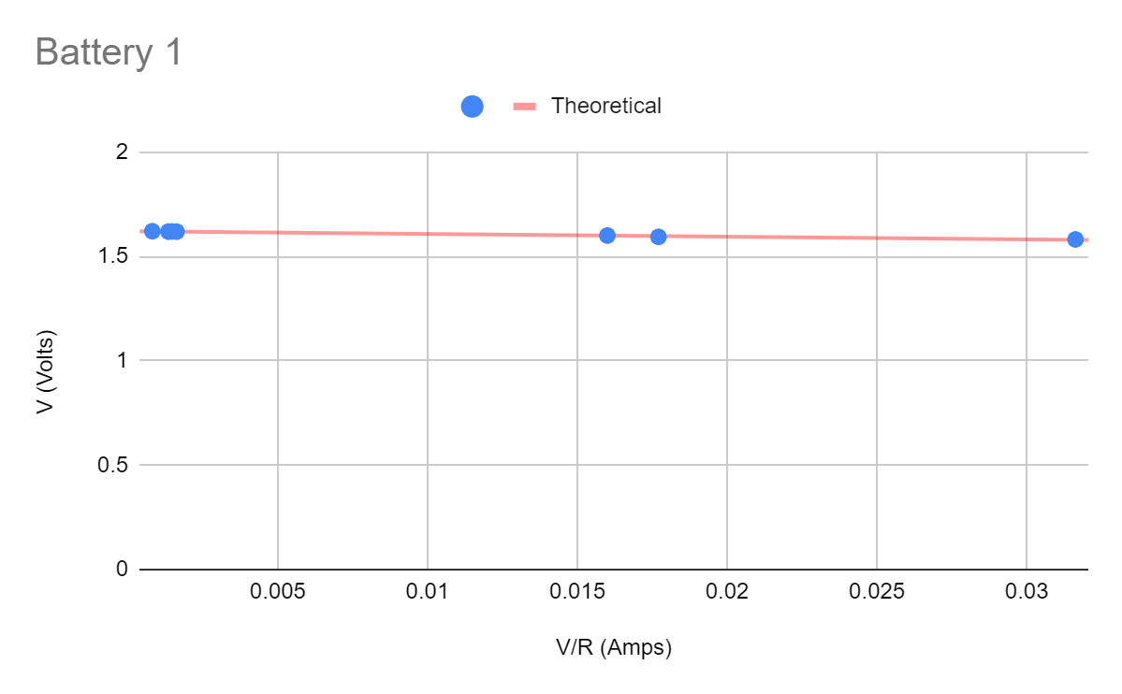

**Task 2 Measurements**

$V_{Battery_{2}}=1.62610$ V

|  |  |  |  |
| --- | --- | --- | --- |
| $R_{Actual}$ (Ω) | $R_{L}$ (Ω) | $V_{L}$ (V) | $V_{Battery}-V_{L}$ (V) |
| 97.903 | 100 | 1.57576 | .05034 |
| 974.6 | 1000 | 1.58951 | .03659 |
| 1954.84 | 2000 | 1.58964 | .03646 |
| 1078.4 | 1100 | 1.5777 | .0484 |
| 1175.77 | 1200 | 1.58208 | .04402 |
| 88.7037 | 90 | 1.60355 | .02255 |
| 48.8793 | 50 | 1.59122 | .03488 |

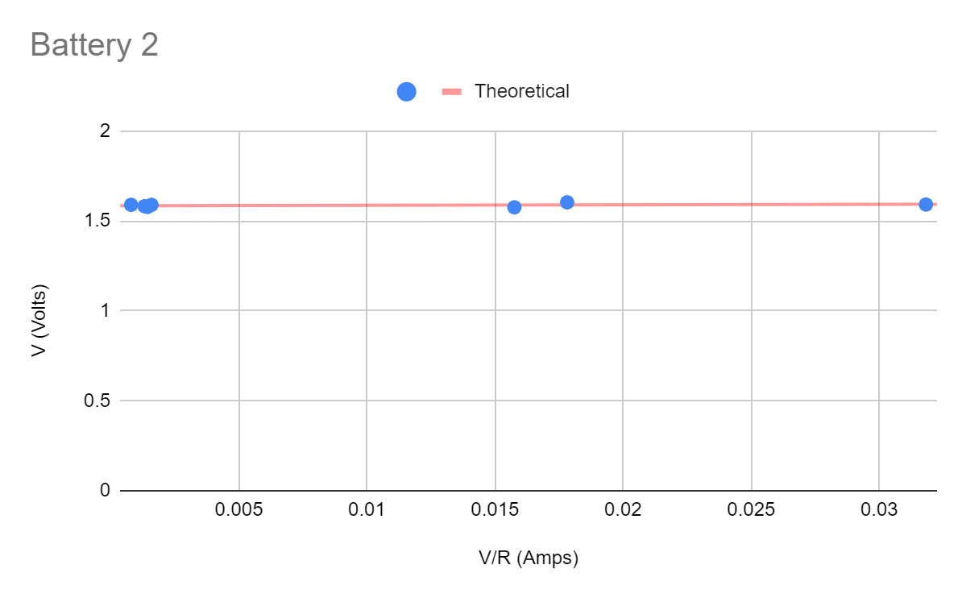

**Task 2 (3V Measurements)**

$V_{Battery_{3}}=3.21475$ V

|  |  |  |  |
| --- | --- | --- | --- |
| $R_{Actual}$ (Ω) | $R_{L}$ (Ω) | $V_{L}$ (V) | $V_{Battery}-V_{L}$ (V) |
| 97.903 | 100 | 3.14719 | .06756 |
| 974.6 | 1000 | 3.20034 | .01441 |
| 1954.84 | 2000 | 3.20856 | .00619 |
| 1078.4 | 1100 | 3.15097 | .06378 |
| 1175.77 | 1200 | 3.17204 | .04271 |
| 88.7037 | 90 | 3.14585 | .0689 |
| 48.8793 | 50 | 3.09477 | .11998 |

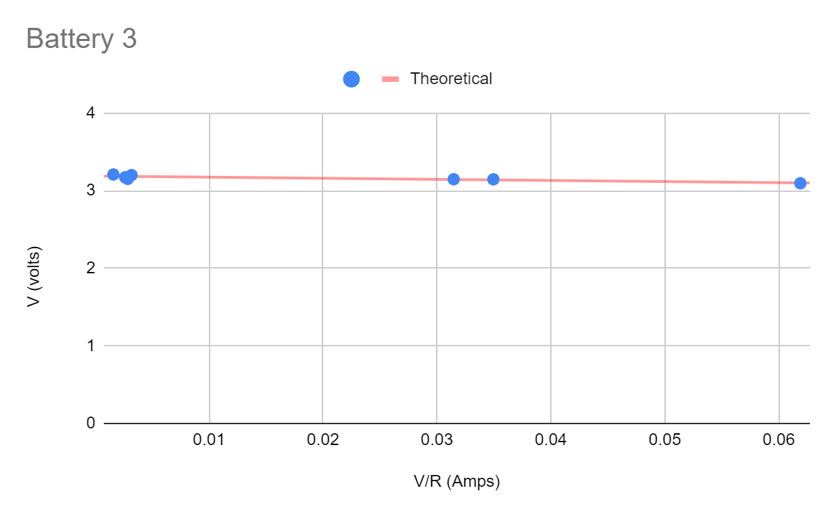

**Calculations**

Most of the data collection in this lab did not involve calculations, although throughout some of the post lab data manipulation, there were a few cases of mathematical calculations.

While collecting the actual data, the only 2 calculations used were:

$R_{Parallel}=R1R2/R1+R2$ $V_{Drop}=V_{Battery}-V_{L}$

The summing of parallel resistors was used to create different sums of resistors for testing. The range of resistor values we used in our lab was 50 - 2000 Ohms. The voltage drop was also calculated for each resistor setup, whether they were wired in series or parallel.

In the post lab, the data collected needed to be manipulated in order to display it correctly in a visual form. In the graphs shown above, the X-axis is Current, while the Y-axis is Voltage. Current was calculated by:

$I_{L}=V_{L}/R_{L}$

We were also supposed to find an estimate of our source values, the internal voltage and resistance of our battery configurations. This was done by fitting a linear regression line to the graphs, and by using the slope and intercepts, we were able to find the source values. The slope of the regression line was defined as the internal resistance, while the intercept defined the internal voltage. The source values came out to be:

$V_{S1}=1.62 V$ $R_{S1}=1.31 Ω$

$V_{S2}=1.58 V$ $R_{S2}=.267 Ω$

$V_{S3}=3.19 V$ $R_{S3}=1.42 Ω$

**Screen Shots from the Tasks**

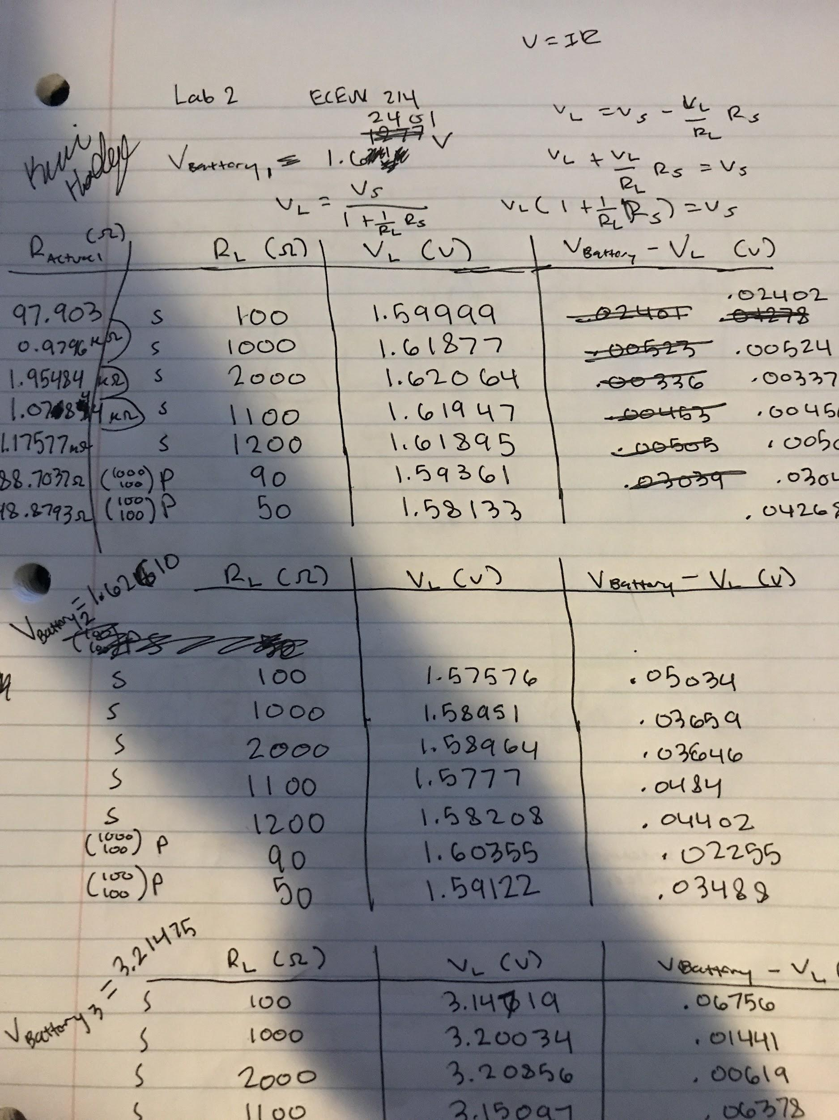

**Discussion**

In the tasks that we performed for this lab, we had to use more than one resistor for most of our measurements. Since we were dealing with such a small voltage, it was practical to use small resistances in the range of 50 to 2000 ohms. We were able to use 2 resistors in both series and parallel in order to obtain these resistances for our measurements. However, as we found in the lab, the actual resistances were not exact to what the resistor’s color band indicated it was. We found that all of the actual resistance measurements were a little below what they should have been.

It is unrealistic for these resistors to be the exact resistance in which they are supposed to be, which is why they have a tolerance level. All of the resistors that we used were within their tolerance levels.

The actual resistance measurements affected the voltage drop across these resistors, which is what was subtracted from the voltage being provided by the voltage source, which should be zero. However, since the resistors were not exact, the voltage drop will not be exact either. This explains why there is a very small amount of voltage that is left when the voltage drop across the resistor(s) is subtracted from the voltage provided by the batteries.

**Conclusion**

In conclusion, Jason and I were able to learn how to set up a simple circuit that had resistors in both series and parallel. Understanding how to measure the voltage drops across the resistors is a simple task that will prove to be helpful in the future. This lab was straight forward and we did not have any issues.